Name: Hong Zhang
Email Address: hzhan121@hawk.iit.edu
Class: ITMD 562 -02
Assignment 2

Project Description: This PHP application which includes 8 PHP files allows the user to create, edit, view, or delete a note. Each note consists of Note ID, Note Subject, Author, Note Content, Total Note Characters and Create or Last Revise Time. The note data is modeled as an object and is saved to data.txt by serializing the list. When reading the data, it will be unserialized. When creating the object, the namespace is used to hold three files which are Note.php, INoteRepository.php and FileNoteRepository.php.

Development Environment:
- Computer OS: Windows 8.1
- Local Server: XAMPP v3.2.1
- Editor: Sublime Text 3
- Internet

Installation Instruction: The index.php is the entry point and will show the note list, let the user add a new note or edit, delete a recorder in the note list. The list include note subject, create or last revise time, total characters and the options to edit or delete this note. When the use wants to edit or delete a note, you can choose the buttons in the index.php or click the note subject which is a hyperlink to show the whole note and allow you to do these two options. When the use tries to delete the note, there will be a confirmation page before deletion.

Insights and Results:
1. Open index.php
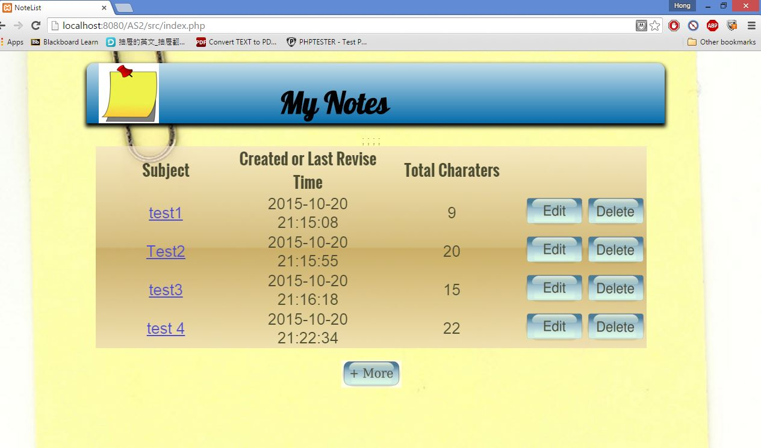

2. Add a new note which goes to create.php
Subject and author are required before saving a note. If not filling in these two fields, the page will show again.
Input will be checked and remove any whitespace or inject javacript.

After checking the validation, save to data.file and show the result.
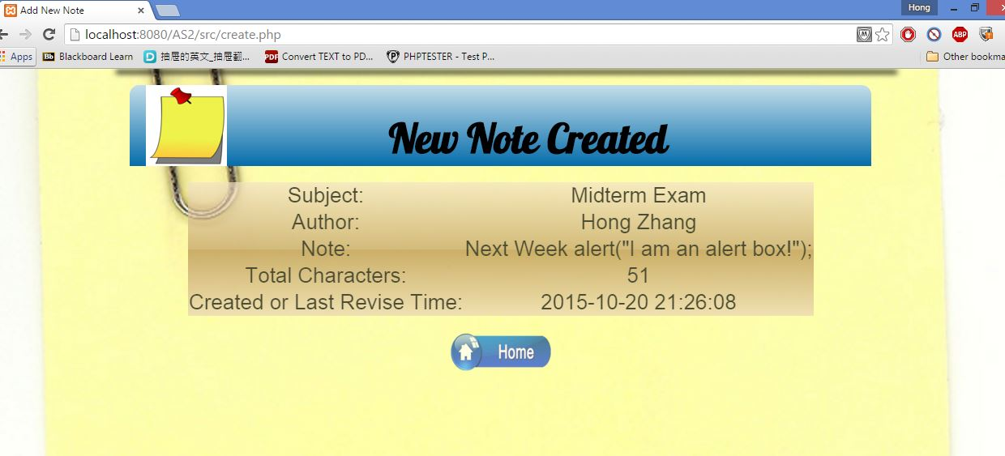
Then, the user can go back to home page, index.php and find the new note.
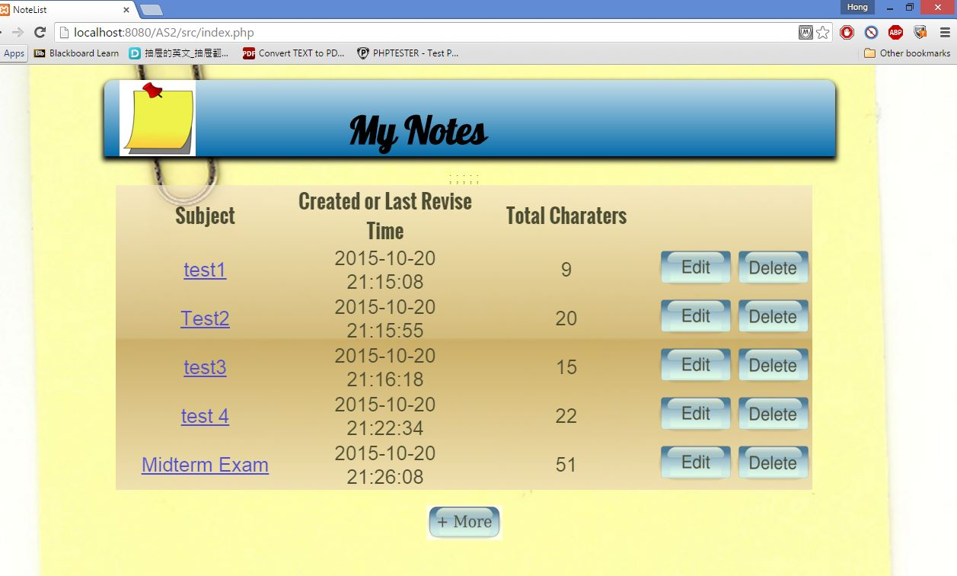

3. Show Note in show.php.
Click the note subject which is a hyperlink to show the whole note.
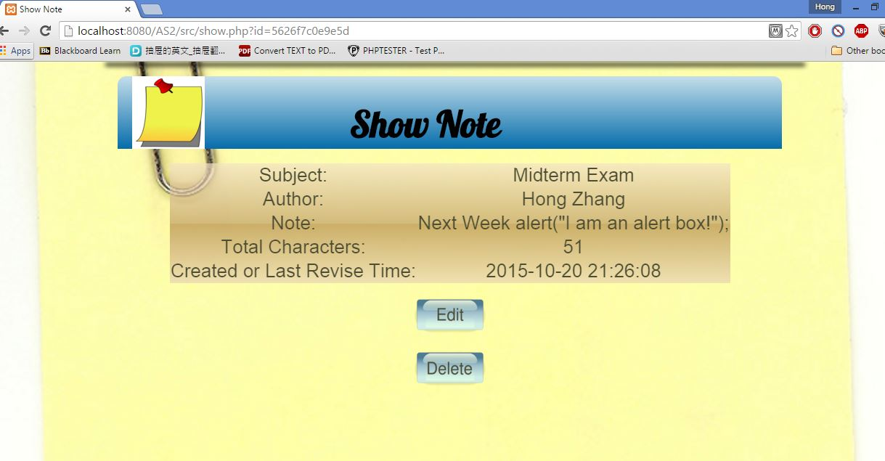

If just open directly show.php without the ID parameter, there is no note to show.

4. Edit a note in edit.php
The user can click the edit button in index page or show page to edit the note. After updating, user can go back the home page.
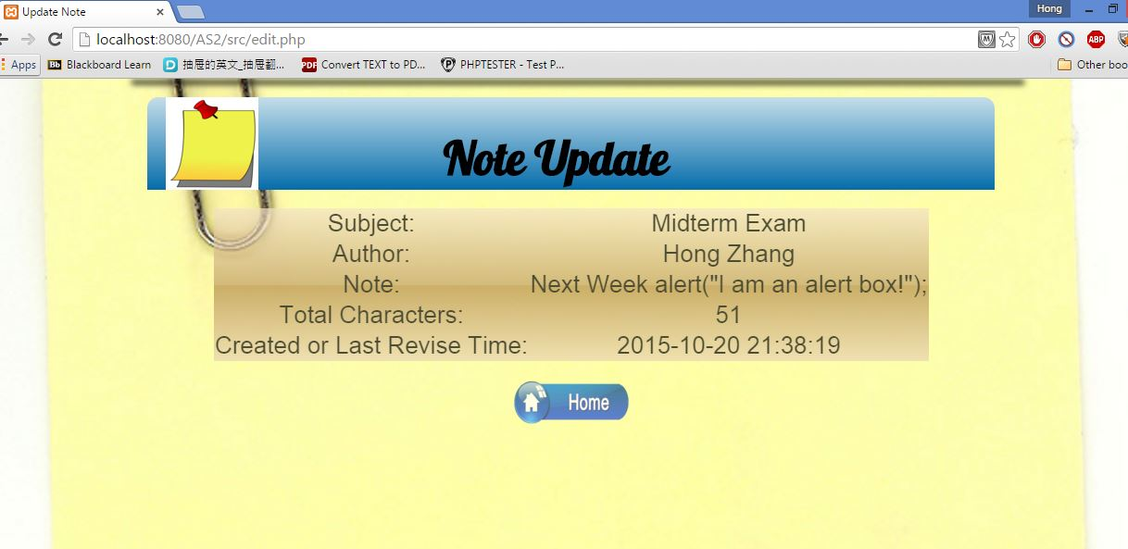
If just open directly edit.php without the ID parameter, there is no note need to be edited.

5. Delete a note in delete.php
User can choose delete button in home page or show page to delete a note. Before deleting this note, there will show the note information and confirm the user’s deleting requirement.
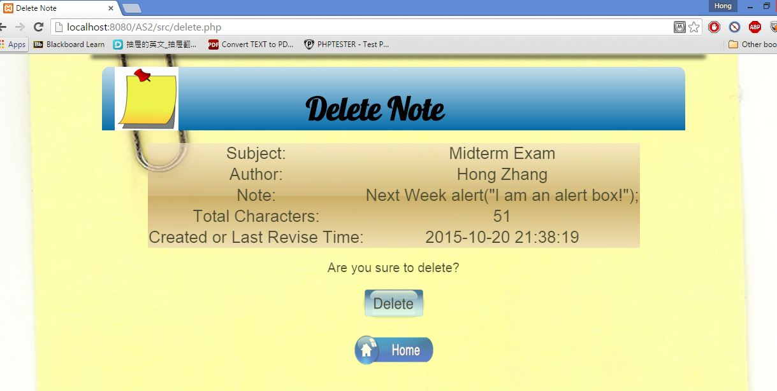
After confirming, the note will be deleted.
User can come back to home page to check it.
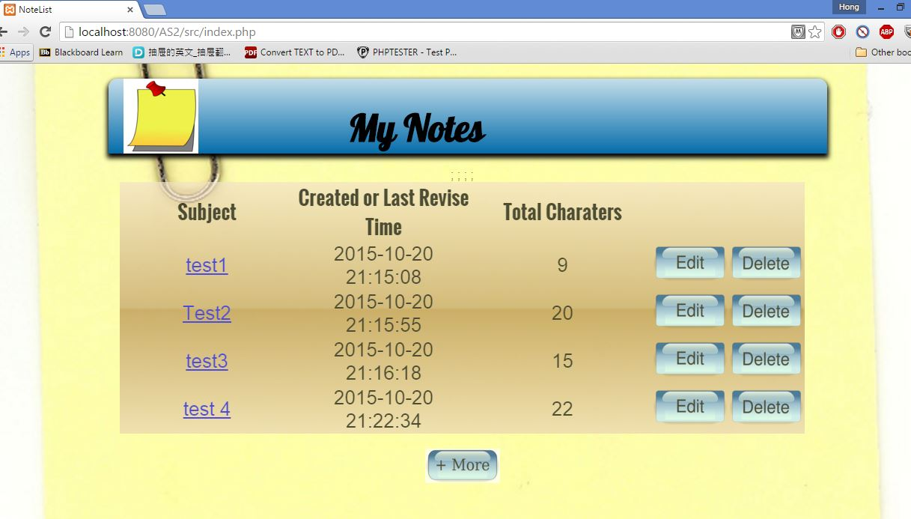
If just open directly delete.php without the ID parameter, there is no note need to be deleted.

